**API Documentation**

**USER**

User attributes:

* _id : ObjectId(auto generated by mongodb)
* Name: String,
* Username: String,
* Password: String(encrypted by bcryptjs)
* Level: String

1. **Create User**

/api/user/create-account

Required Field:

* name
* username
* password
* level
* email(optional)
* address(optional)



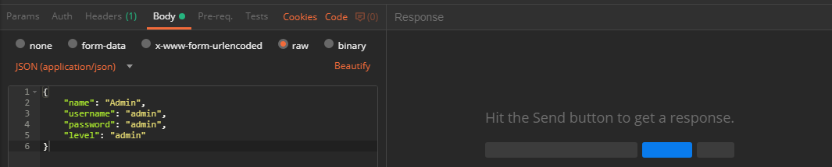

Response:

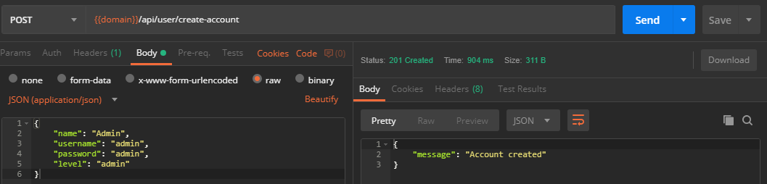

1. **Login User**

/api/user/login

Required Field:

* username
* password



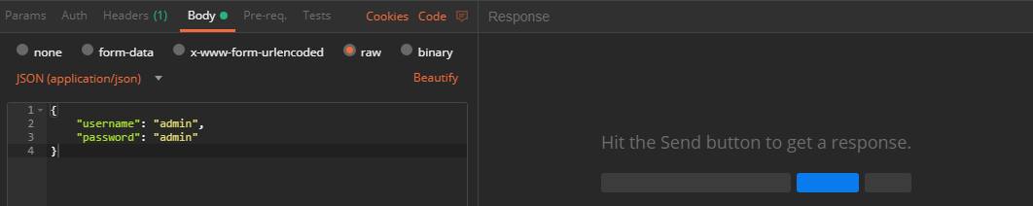

Response :

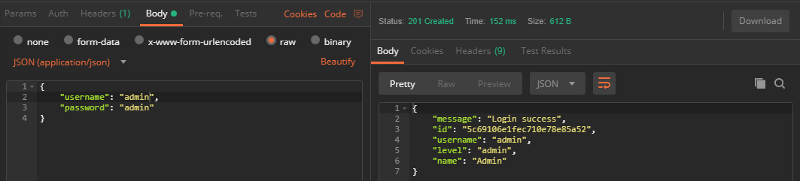

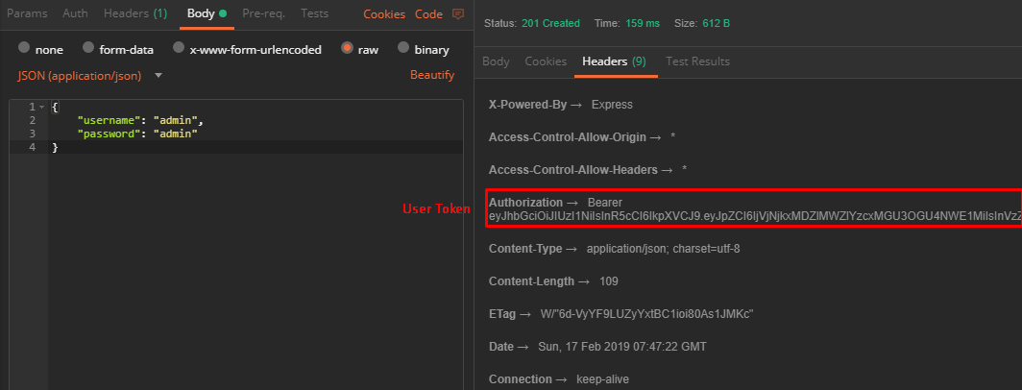

User Not Exist

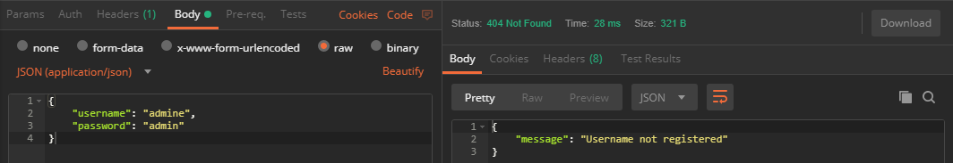

Wrong Password

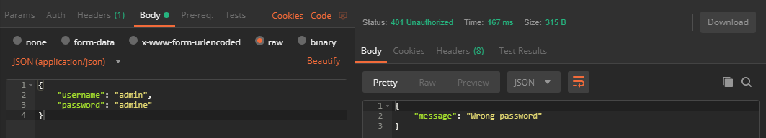

1. **Update User**

/api/user/:id

Required Field:

* name
* username
* password
* level
* email(optional)
* address(optional)



Response

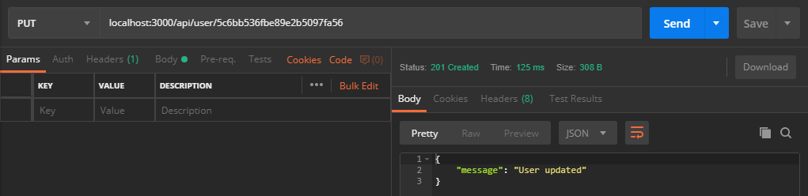

1. **Delete User**



Response

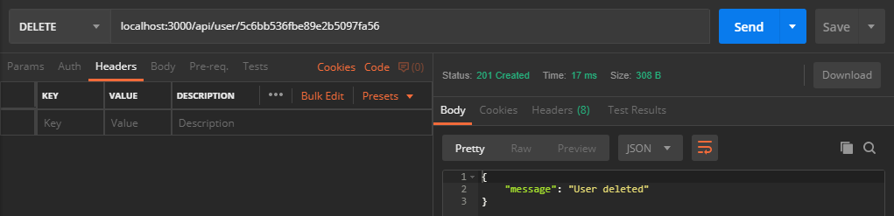

**FURNITURE**

Furniture attributes:

* _id : ObjectId(auto generated by mongodb)
* Name: String,
* Description: String,
* Price: Number
* Quantity: Number
* Cat_id: Number
* Images: Array of String(auto generated by upload middleware, get executed after auth middleware accepted, maximum image=10)
* Item_code: String
* Creator: ObjectId(auto generated by auth middleware)

1. **Create Furniture**

/api/furniture/

Required Header:

Authorization : Bearer <USERTOKEN>

Required Field:

* name
* description
* price
* quantity
* cat_id
* images
* item_code
* creator



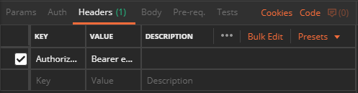

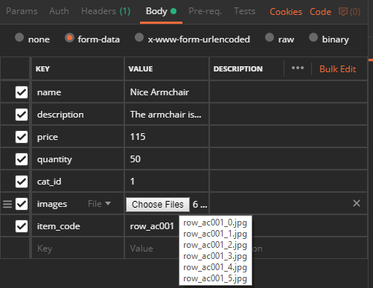

Response:

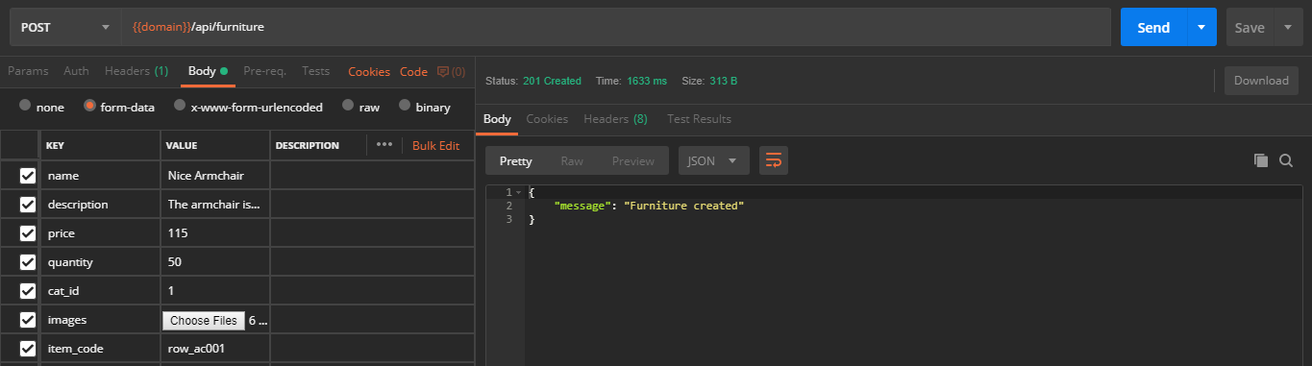

1. **Get All Furniture**

/api/furniture



Response

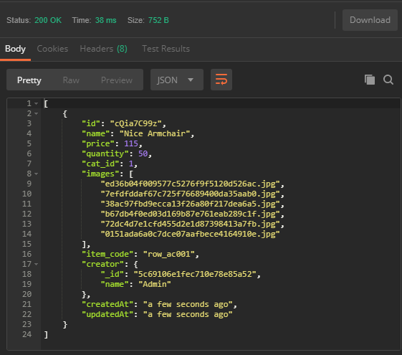

Description Field hidden to minimize the request bandwidth, only shown in furniture detail

1. **Get Furniture By Id**

/api/furniture/:id



Response :

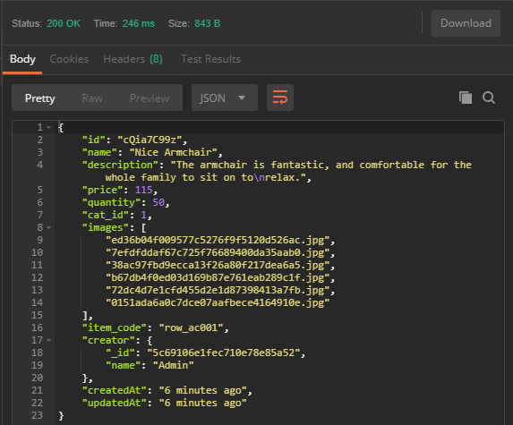

Furniture Id Not Exist

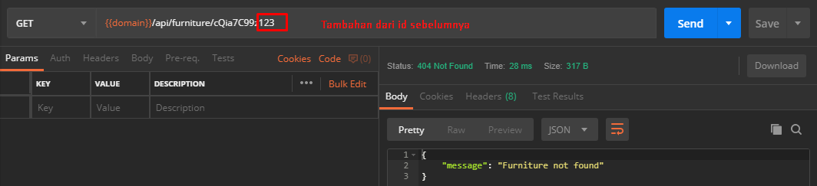

1. **Update Furniture**

/api/furniture/:id

Required Header:

Authorization : Bearer <USERTOKEN>

Required Field:

* _id
* name
* description
* price
* quantity
* cat_id
* images
* item_code
* creator



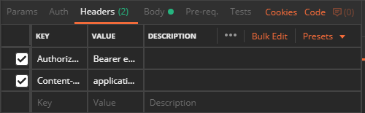

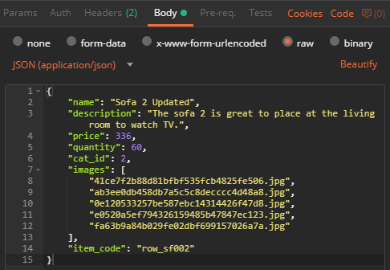

Response :

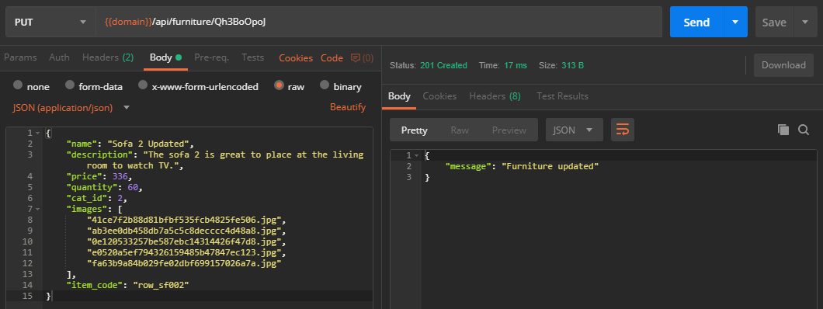

Furniture not exist

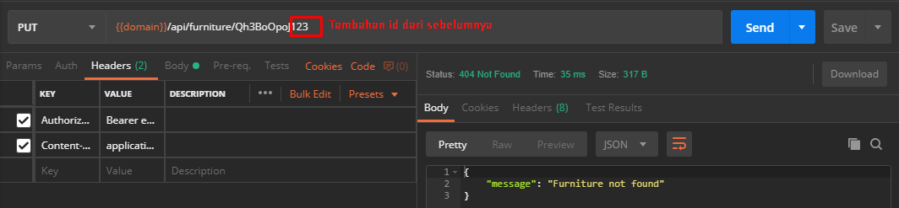

Not authorize (without USERTOKEN)

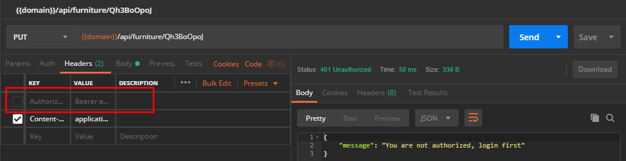

Hasil Update

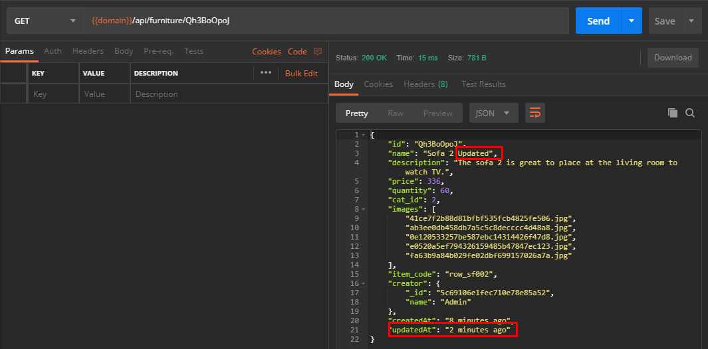

1. **Delete Furniture**

/api/furniture/:id

Required Header:

Authorization : Bearer <USERTOKEN>





Response :

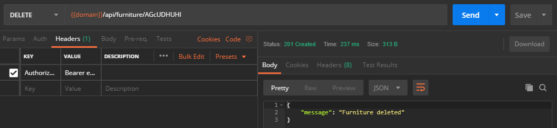

Furniture not exist (try to delete the same futniture that already deleted)

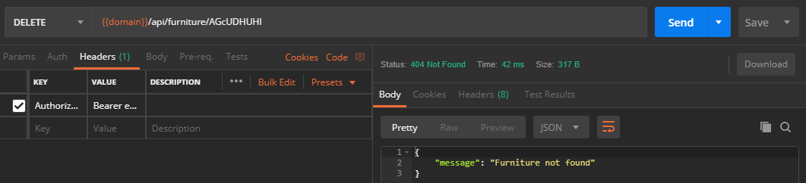

Not authorize (without USERTOKEN)

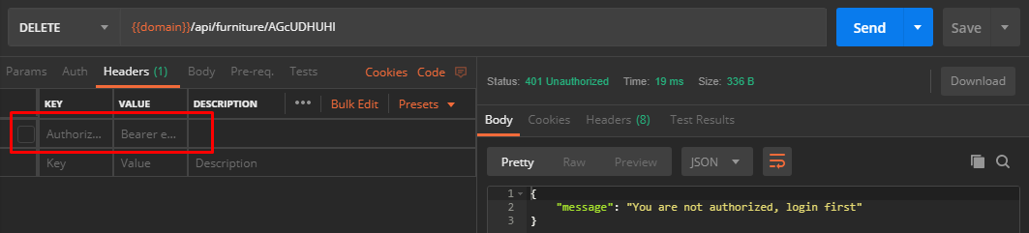

1. **Get Furniture by Category**

/api/furniture/category/:id



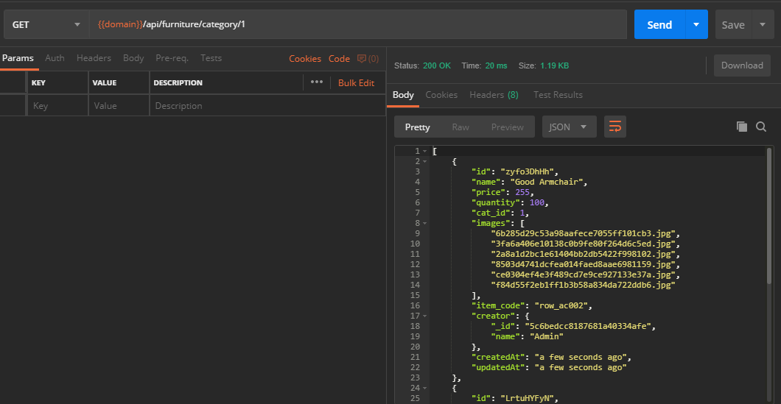

Response :

**TUGAS**

1. Menambahkan field pada data furniture

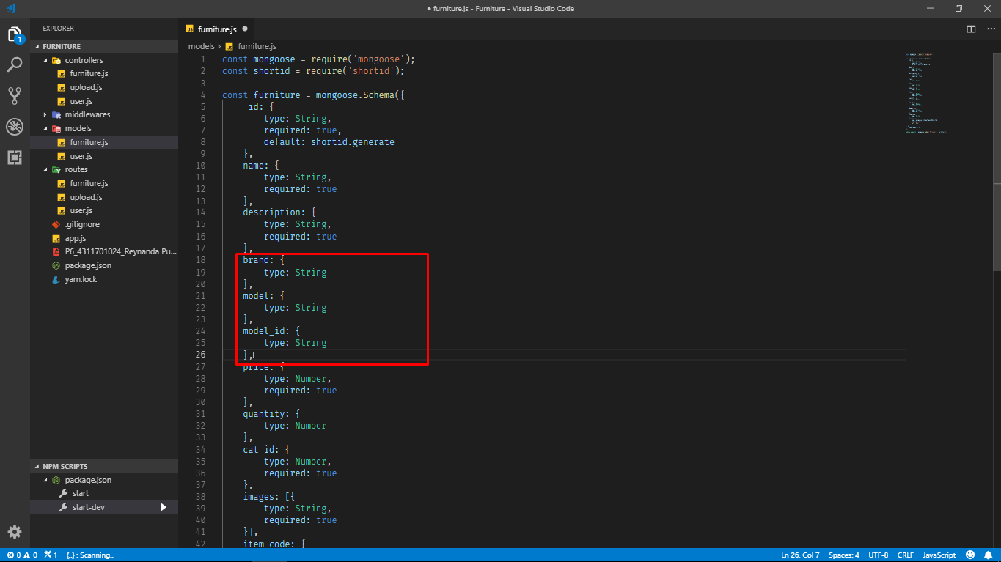

1. …

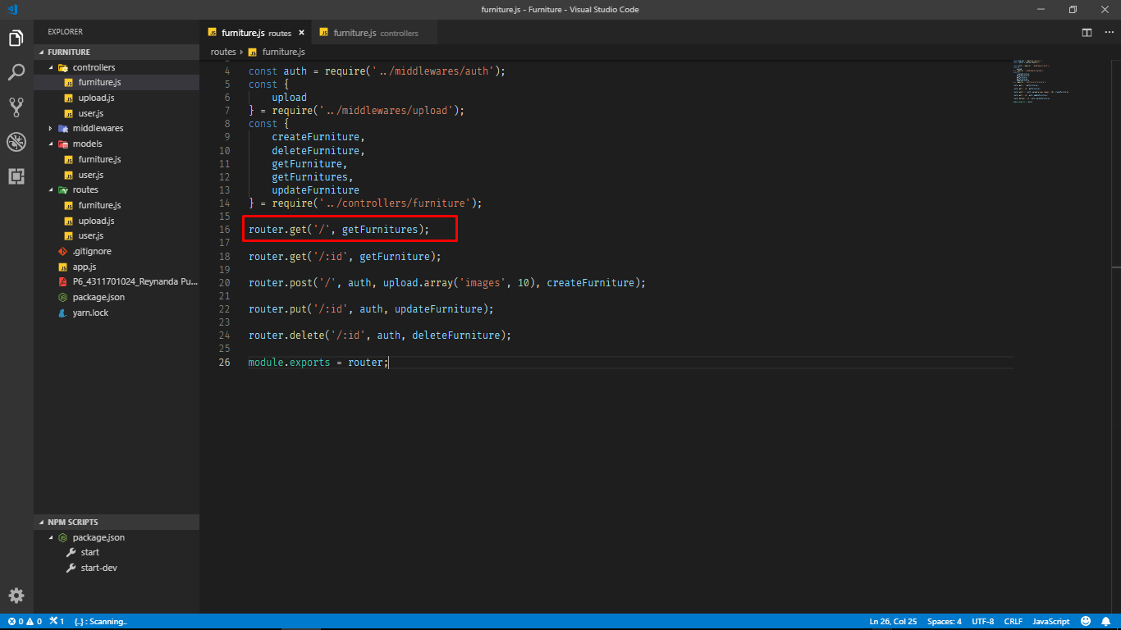

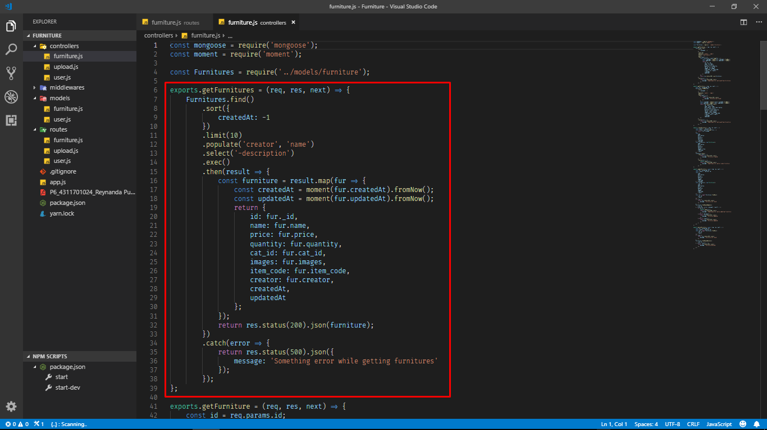

1. Menambahkan field pada data furniture

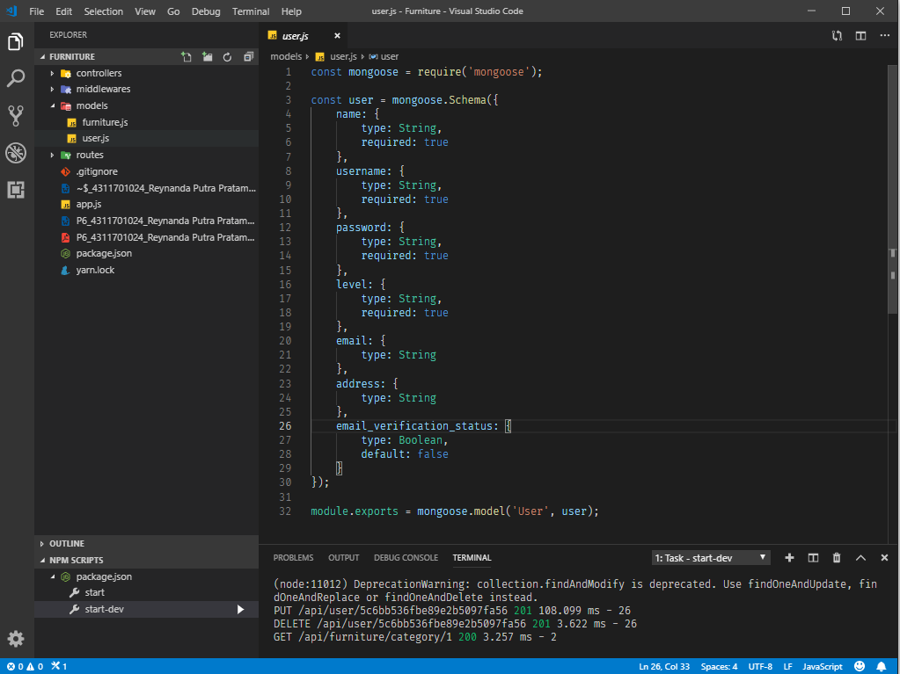

1. Untuk menambahkan data, user harus mengupdate data user. Dengan menambahkan field yang barusan ditambah pada saat proses update seperti dokumentasi diatas, kecuali email_verification_status. Karna secara default akan memiliki value false.
2. Untuk mengganti data, user juga harus mengupdate data user. Dengan menambahkan field yang barusan ditambah pada saat proses update seperti dokumentasi diatas